
household carbon budget planner
C project
TEAM MEMBERS

Nalabati H S N S Vaishnavi[team lead]-25A31A0585
Nallajarla V N S Lakshmi Kavya-25A31A0586
Nalla Kashyap Shrivatsa-25A31A05AT
Peneddy Veera Venkata Satyanarayana-25A31A05AU
GUIDED BY
Mr. Y. MANAS KUMAR
ASSISTANT PROFESSOR
CSE DEPARTMENT PRAGATI ENGINEERING COLLEGE(A),SURAMPALEM

project DESCRIPTION: household carbon budget planner

1. Introduction
Climate change represents the most significant existential challenge of the 21st century. While industrial regulations are critical, a substantial portion of global greenhouse gas emissions—estimated at over 60%—is influenced directly by household consumption decisions. These include energy usage, transportation habits, dietary choices, and waste management. Despite growing environmental awareness, most individuals lack the necessary tools to quantify their impact accurately. The Household Carbon Budget Planner (HCBP) is a proposed digital solution designed to bridge this information gap, transforming abstract climate concerns into measurable, manageable, and actionable daily habits.
2. Problem Statement
The core issue facing environmentally conscious individuals is the "invisibility" of carbon emissions. In the financial world, mobile banking provides instant visibility into spending habits, allowing for immediate course correction. In contrast, "carbon balances" remain invisible until the aggregate environmental damage is done. Existing tools in the market are predominantly static, web-based calculators that offer a one-time annual estimate. They fail to account for daily fluctuations, lack integration with modern real-time data sources, and do not provide the feedback loops necessary to drive genuine behavioural change. Without granular data, households cannot effectively track their progress against specific climate targets, such as the Paris Agreement’s 1.5°C goal.
3. Proposed Solution
The HCBP is a comprehensive cross-platform application (Web & Mobile) that introduces the concept of a "Carbon Wallet." Functioning similarly to a financial expense tracker, the system allows users to set a specific monthly "Carbon Budget" measured in kilograms of CO₂ equivalent (kg CO₂e). The application aggregates data from various aspects of daily life to track consumption against this limit in real-time. By treating carbon emissions as a finite currency, the system psychologically nudges users towards conservation and efficiency.
4. Key Features and Functionality
The system is built upon four core pillars:
- Dynamic Baseline & Smart Budgeting: Upon registration, users complete a detailed lifestyle audit (home size, heating type, commute habits). The system establishes a baseline footprint and recommends a personalized monthly budget. This budget can be aligned with national averages or personal reduction goals (e.g., a 10% year-over-year reduction).
- Automated Multi-Source Tracking: To reduce user friction, the HCBP utilizes automation:
  - Energy: Integration with smart meter APIs to fetch electricity and gas usage data automatically.
  - Mobility: Background GPS tracking algorithms distinguish between walking, driving, and public transport, calculating emissions based on distance and vehicle efficiency.
  - Consumption: An "Open Banking" module analyses transaction categories (e.g., fuel, groceries, airline tickets) to estimate the carbon intensity of purchases using spend-based emission factor.
- Gamification & Community: To sustain long-term engagement, the platform includes leaderboards, achievement badges for staying under budget, and neighbourhood challenges, fostering a sense of community responsibility.
- AI-Driven Recommendation Engine: A machine learning model analyses user behaviour to identify "emission hotspots." It provides personalized, high-impact suggestions, such as "Switching your commute to a bus twice a week will save 15kg CO₂ e, keeping you under budget."

5. Expected Impact
The Household Carbon Budget Planner aims to democratize climate action. By converting complex scientific data into tangible metrics, it empowers users to take ownership of their environmental footprint. The project is expected to result in measurable reductions in household emissions, significant utility cost savings for users, and the generation of anonymized data that can assist local governments in planning sustainable infrastructure.

System Architecture
Description Of Architecture
This carbon footprint tracking application employs a hub-and-spoke architecture centred on the Main Dashboard, accessible after user authentication.
The system comprises three primary functional modules. The Input Data module captures user activities across energy consumption, transportation, food, and waste categories, feeding into a calculation engine that computes carbon emissions using standardized factors. The View Reports module generates comprehensive reports that users can export or share, promoting transparency. The Set Goals module allows users to establish carbon budgets for targeted emission reduction.
All processed data flows into a centralized Data Storage layer, ensuring historical tracking and data persistence across sessions.
The Analytics & Insights engine serves as the intelligence layer, processing stored data to deliver three key outputs: visual charts displaying emission trends, automated budget alerts for threshold monitoring, and AI-powered recommendations for carbon reduction strategies.
The architecture implements a continuous feedback loop, with all analytical outputs cycling back to the Main Dashboard. This creates an iterative improvement system where users monitor progress, receive personalized guidance, and adjust behaviour based on data-driven insights, ultimately supporting sustainability

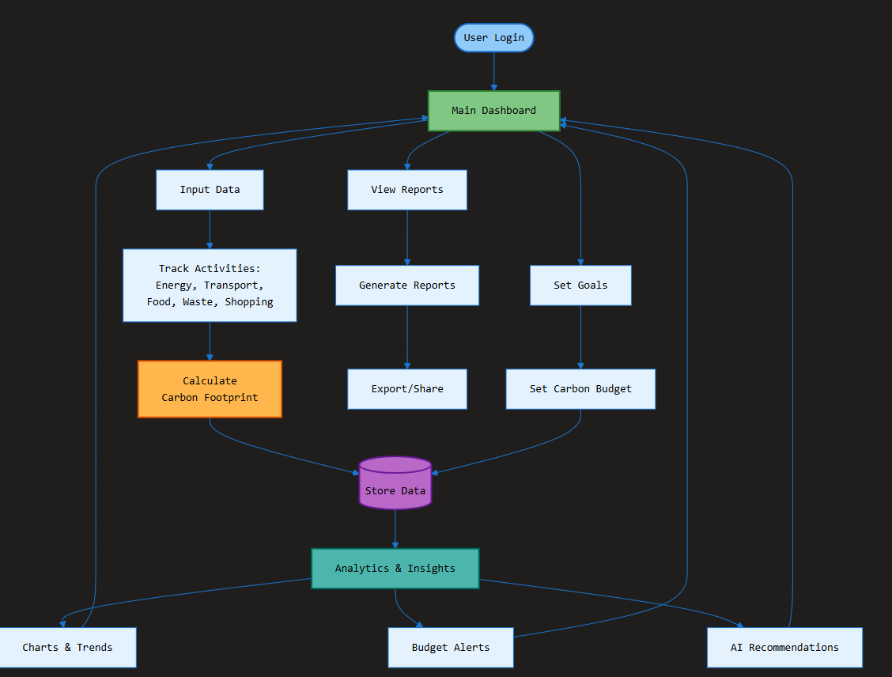

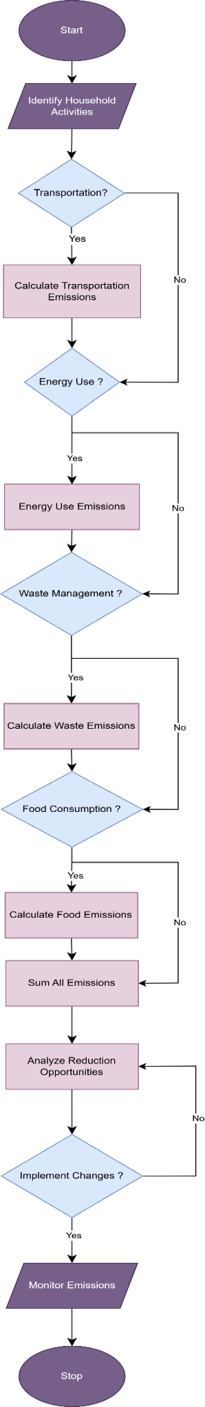
Operational Flowchart

